# Pathfinder 2nd Edition Randomizer

### What is Pathfinder 2nd Edition?

A tabletop roleplaying game, or TTRPG, published by Paizo! Realistically, if you aren’t familiar with PF2, you won’t have much use for this Randomizer. If you’re looking to start learning and playing PF2, I recommend you visit the [Archives of Nethys introduction page](https://2e.aonprd.com/PlayersGuide.aspx). Regardless, here’s a basic rundown of the relevant terms from PF2 that are used in this tool:

* **Feat:** A feat in PF2 is a choice that a character can select, granting them some ability or other useful thing. Feats have associated levels, come from certain sources (such as a character’s ancestry or class), and often have **prerequisites** that the character must meet before they can be selected. Although technically it’s a different thing, this guide will also refer to various **features** as feats, because they are largely selected the same way.
* **Prerequisite:** Something necessary for a character to have before selecting a feat. Usually the prerequisite is itself another feat or feature, but it can be other things too.
* **Level:** All feats have an associated level, which is the minimum level a character must be to select the feat. This might sound like a prerequisite, and functionally it pretty much is, but in practice we keep the indication of the level distinct because it’s always a part of the feat selection process.
* **Rarity:** The four rarity tiers are common, uncommon, rare, and unique. They’re useful for a Gamemaster to have finer control over what’s allowed in their game. In this tool, the different rarities impact how often a feat is presented.

### What is this?

The PF2 Randomizer is a tool that can return randomly generated PF2 feats or features from defined categories. The original purpose of this was to help facilitate playing a game of PF2 in the style of a roguelike, a genre of gaming at least partially defined by its use of randomization. However, this can be useful for whatever other reasons you might want to generate random feats, such as simply wanting to be given a feat without having to analyze and compare them all.

### What is this not?

This is not a character sheet or character builder! While it can save character-specific information about what prerequisites they do or don’t meet, it isn’t really functional for any other purpose that those sorts of tools would be for. You will need your own separate character sheet if you want to record decisions made using this tool. A popular option I’d recommend is [Pathbuilder](https://pathbuilder2e.com/app.html).

### Design Elements

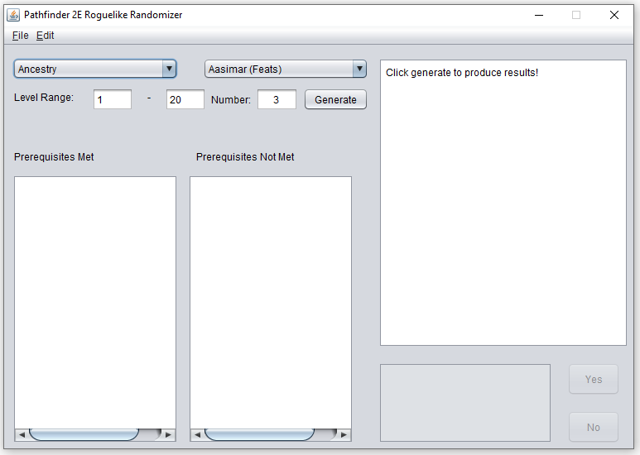

Elements listed generally from top to bottom, left to right:

* **File Menu:** This contains the **Save** and **Load** options. These can be used to either save the current lists of prerequisites to a file, or to load such a file so that the lists are available for immediate use.
* **Edit Menu**: This contains the **Merge**, **Configure Weights**, and **Clear Prerequisites** options.
  + The **Merge** option brings up a popup window where two feat categories can be selected, and then creates a new feat category including both.
  + The **Configure Weights** option brings up a popup window where the weighting of different rarities of feats can be adjusted.
  + The **Clear Prerequisites** menu includes two sub-options, one for clearing both lists of all prerequisites, and one for another popup window where individual prerequisites can be removed from either list.
* **Supercategory Dropdown:** This dropdown selects from *Ancestry, Class, Subclass, and Other*. This controls the selection available in the category dropdown.
* **Category Dropdown:** This dropdown selects a specific category from which to generate the random feats. For example, in the supercategory Ancestry you can select to generate feats from those available to Aasimar.
* **Level Range:** These text fields indicate what levels of feats should be generated from, inclusively. They default to 1 and 20, the minimum and maximum levels.
* **Number:** This indicates how many random feats you want to generate. By default, it’s set to 3, as this is the number of choices available from most categories when using the roguelike rules.
* **Generate Button:** This button will use the choices made in other fields to generate a number of random feats. If a feat is chosen that includes prerequisites, it will automatically compare these prerequisites against the ones that have been recorded, and prompt about whether the prerequisite is or isn’t met if it’s not recorded.
* **Results Display:** This large area in the upper right of the window will display the feats that are generated.
* **Prerequisites Met/Not Met Displays:** These will list all of the prerequisites that are recorded as having been met or not met.
* **Prerequisite Confirmation Display:** This display and its corresponding buttons are only enabled when prompting about whether or not a feat’s prerequisites are met. The display will indicate the prerequisite in question, and the Yes and No buttons are used to record if the prerequisite is met or not met respectively.

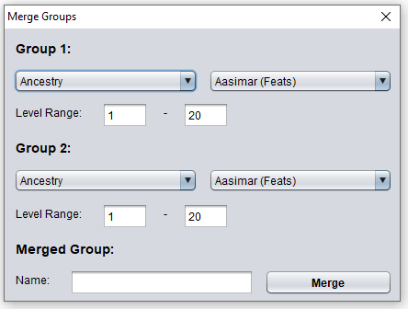

* **Merge Group 1 and 2 Selections:** These dropdowns and associated fields function just as the supercategory and category dropdowns and the level range fields in the main display do, and can be used to select two categories of feats (groups) that are to be merged.
* **Name Entry Field:** This is used to give a group about to be merged its name.
* **Merge Button:** This will perform a merge of the two above selected groups, creating a new merged group with the provided name. The new group will be included in the ‘Other’ supercategory.

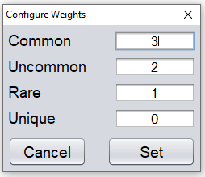

* **Rarity Weight Entry Fields:** These fields show the four rarities and their weightings (3, 2, 1, and 0 by default). The higher the weight given, the more likely a rarity is to show up, as a ratio with the other weights. To prevent a certain degree of rarity from appearing, its weight should be marked as 0.
* **Cancel and Set Buttons:** The set button will finalize any change in the weightings shown. The cancel button will exit the window without applying the changes in weights.

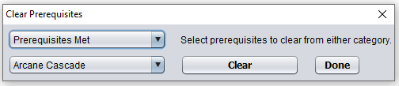

* **Met or Not Met Dropdown:** This dropdown indicates which prerequisite list is being removed from.
* **Prerequisite Dropdown:** This dropdown offers a selection of all prerequisites recorded in the chosen list. In the example above, the prerequisite is ‘Arcane Cascade’.
* **Clear Button:** This removes the currently selected prerequisite from the chosen list.
* **Done Button:** This closes the popup window.

### Tutorial

In order to demonstrate the use of this tool, we’ll walk through a hypothetical scenario where you are a player in a game for which your GM wants to use a custom procedure for generating a roguelike experience. Firstly, your GM has declared that he is equally fine with all common and uncommon options, but won’t allow rare or unique ones. To meet his standards, click on the **Edit** menu, and then on **Configure Weights**.

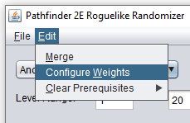

This will bring up a dialogue box with each of the rarities and their weights. Make sure that **Common** and **Uncommon** are both set to the same positive number - let’s say 3 - and that **Rare** and **Unique** are both set to 0.

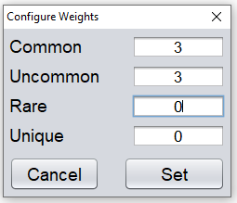

Make sure to hit the **Set** button in order to finalize these changes. Now that we’re following our GM’s rules for feat selection, it’s time to start generating the options we’ll use for our character. The GM has stated that the very first selection will be the character’s ancestry, and that it will be truly random, meaning that only one choice will be presented. To select a single ancestry, change the **Supercategory** dropdown to ‘Other’. You’ll notice that Ancestry is one of the supercategories, but in this case, you want it as the category itself, which is found in Other. Then, set the **Category** to ‘Ancestries’. Finally, in the **Number** field, indicate that we want only 1 selection. Now, hit **Generate**!

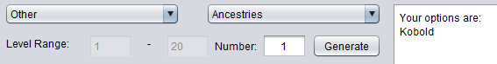

Make a note of whatever ancestry you generated - in this example, I generated ‘Kobold’. The next step of creating our character will be selecting a Background. The GM is giving more flexibility for this choice, and has told you to pick from 3. The ‘Backgrounds’ **Category** is in the same **Supercategory** ‘Other’, so select it, then update the **Number** field to read 3, and hit **Generate**.

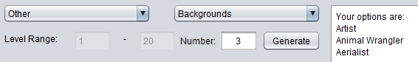

I’ve been given the options of ‘Artist’, ‘Animal Wrangler’, and ‘Aerialist’. Pick your favorite option and note it on your character sheet (I have a preference for the Aerialist background, since Acrobatics is a useful skill). Finally, we’ll pick the most important basic feature we have - our class! This can also be found in ‘Other’, and since our GM wants us to have a solid range of 4 choices, we’ll set **Number** to 4 before hitting **Generate**.

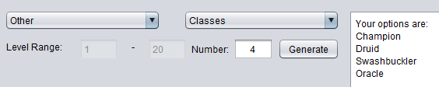

Again choose your preferred option, and make a note of it on your character sheet. Because kobolds have a Dexterity and a Charisma boost and Swashbuckler makes good use of both such ability scores, I might choose Swashbuckler.

Now that we’ve been assigned the basics of our ABCs (Ancestry, Background, Class), the next step is to pick our heritage. For simplicity’s sake, the GM is not allowing Versatile Heritages, meaning we’ll only pick from the actual ancestry-specific heritages. For this, you’ll want the **Supercategory** ‘Ancestry’ and the **Category** ‘Kobold (Heritages)’, or whichever category of heritages is appropriate to the previously generated ancestry. The GM has told you to pick from 2 heritages. Set the **Number** field to 2 and hit **Generate**.

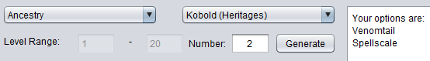

Now, our next step is to select a level 1 ancestry feat, for which the GM is giving us a choice of 3. Keeping our **Supercategory** the same, we now want to select for our **Category** the ‘(Feats)’ option for the same ancestry we generated our heritages from. Finally, since we only want level 1 ancestry feats, change the **Level Range** to indicate a maximum and minimum level of 1. To generate 3 choices, set **Number** to 3 and hit **Generate**.

It’s possible that this will be the first time we’ll encounter prerequisites; if this occurs, the generation process will pause and a prompt will appear in the lower right **Prerequisites Confirmation Display**. It will ask if you meet the shown prerequisite, which for a level 1 ancestry feat will probably be either a specific heritage or a specific skill, such as ‘Crafting’ or ‘Performance’. If you meet the prerequisite, such as by having the shown heritage or being trained in the shown skill, click the **Yes** button. Otherwise, click **No**. Since you haven’t decided most of your skills yet at this point, your GM is letting you count as meeting the prerequisites requiring skills, provided you actually select them later when you’re finalizing your character.

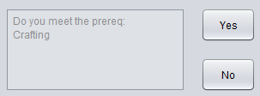

Notice that the prerequisites you meet or don’t meet are now recorded in the lists on the bottom left and middle of the tool. Once all prerequisite prompts have been answered, the generated choices will appear in the **Results Display** as usual.

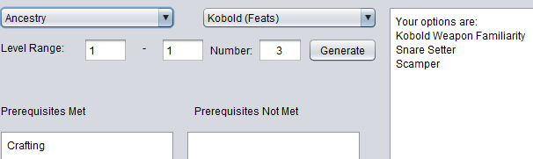

In the above example, I indicated that my character was trained in Crafting, and was given a choice of three level 1 kobold feats to select from. Again, we’ll pick our preferred feat and note it on our character sheet.

The steps we must follow at this point vary based on our class, specifically based on if our class offers a choice of subclass and level 1 feat. For the kobold Swashbuckler I’ve been making so far, I have both! We’ll handle the subclass first. The choice of the ‘Swashbuckler Styles’ **Category** is listed under the ‘Subclass’ **Supercategory**. Since there aren’t many subclasses to choose from for most classes, the GM has chosen to allow only a choice of 2, which we’ll put into the **Number** field as normal and **Generate**.

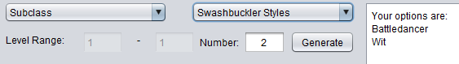

After picking a style, we can handle our level 1 class feat. Using the **Supercategory** ‘Class’ and the **Category** ‘Swashbuckler’, a **Level Range** only allowing level 1 feats, and 3 choices for our **Number**, we can hit **Generate** for the final time.

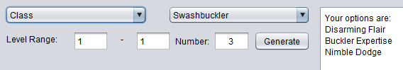

This is the last choice about feats or features that we need to make for our level 1 Kobold Swashbuckler! Before finishing, we can open the **File** menu and hit **Save** in order to save the lists of prerequisites we do and don’t meet, in case we come back to this character again at level 2. At that point, we would open the **File** menu and **Load** it.